PhD scholarship on the Bilingual/Multilingual Brain
The Faculty of Modern Languages and Communication at UPM is a beneficiary in The Multilingual Mind (MultiMind), a project funded by the European Union's Horizon2020 research and innovation programme under the Marie Skłodowska Curie grant agreement No 765556. MultiMind is an international multidisciplinary and multisectorial training network on multilingualism and it supports fifteen 3-year PhDs positions at various institutions, from September 2018.
UPM will host one position. The PhD student will be supervised by Associate Professor Dr Yap Ngee Thai and co-supervision by Dr. Christos Pliatsikas and Professor Doug Saddy from University of Reading. The project involves investigating the brain structure and connectivity in the multilingual and multiliterate brain. The student will complete a six-month secondment at the University of Reading.
We are accepting applications now!! Deadline: 30 June, 2018
Click here for the eligibility criteria for MultiMind (look for ESR6 for position in UPM) and here for the application procedure.
For further information, contact the principal investigator at UPM, Associate Profeesor Dr Yap Ngee Thai at ntyap@upm.edu.my.

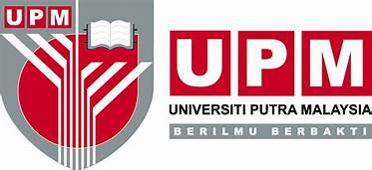
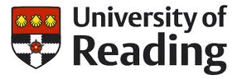 | This project has received funding from the European Union's Horizon2020 research and innovation programme under the Marie Skłodowska Curie grant agreement No 765556.

